

**The State of Data Collaboration: Beyond Data Clean Rooms**

In the ever-evolving world of digital marketing, data is the lifeblood of effective decision-making. Companies rely heavily on audience insights to drive segmentation, personalization, and campaign outcomes. However, as the ecosystem becomes more complex and privacy regulations tighten, the traditional methods of data sharing and utilization are under strain. This has left many marketers questioning the effectiveness of current tools like data clean rooms and seeking more innovative solutions.

**The Promise and Pitfalls of Data Clean Rooms**

Data clean rooms (DCR) emerged as a privacy-compliant way to share and analyze data between companies without exposing raw first-party data. They promised a secure environment where organizations could collaborate to gain mutual insights. However, many marketers are finding these tools fall short of expectations and in many cases too costly to scale.

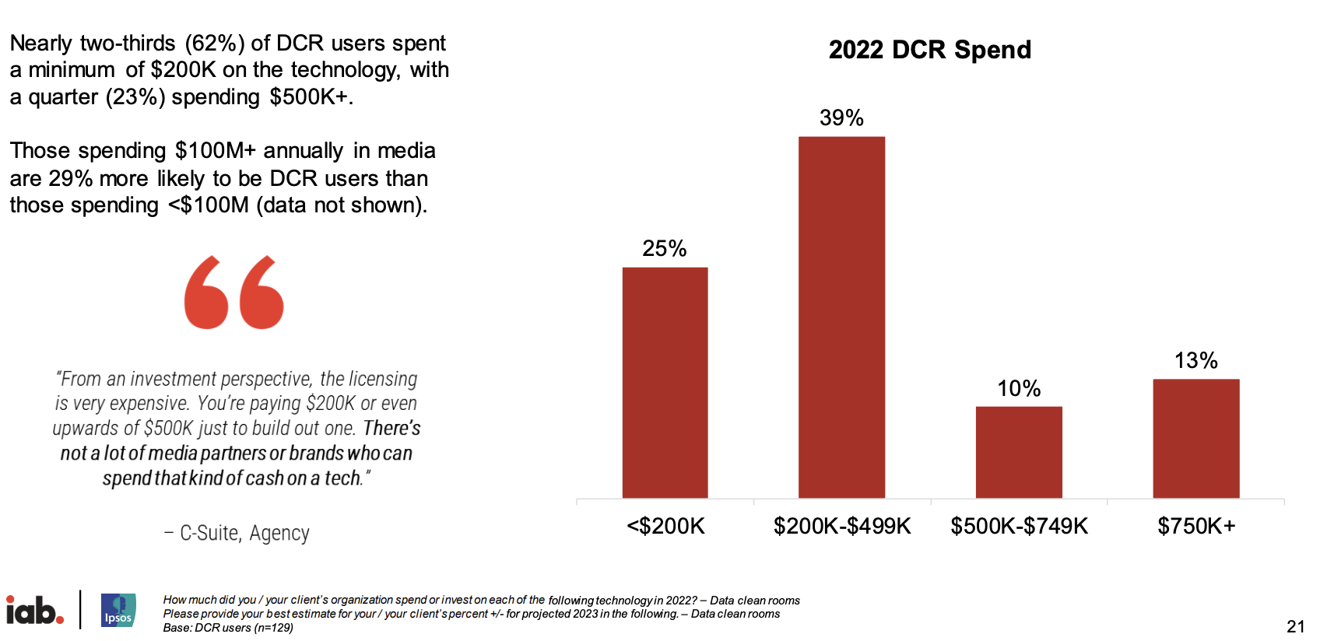

Source: [IAB State of Data](https://www.iab.com/wp-content/uploads/2023/01/IAB_State_of_Data_2023.pdf)

Challenges such as limited scalability, complex implementation, and lack of real-time integration have created friction. Furthermore, clean rooms often operate as walled gardens, restricting the flexibility needed to blend diverse datasets seamlessly. These limitations have left organizations struggling to unlock the full potential of their first-party data or to achieve the level of collaboration needed to stay competitive.

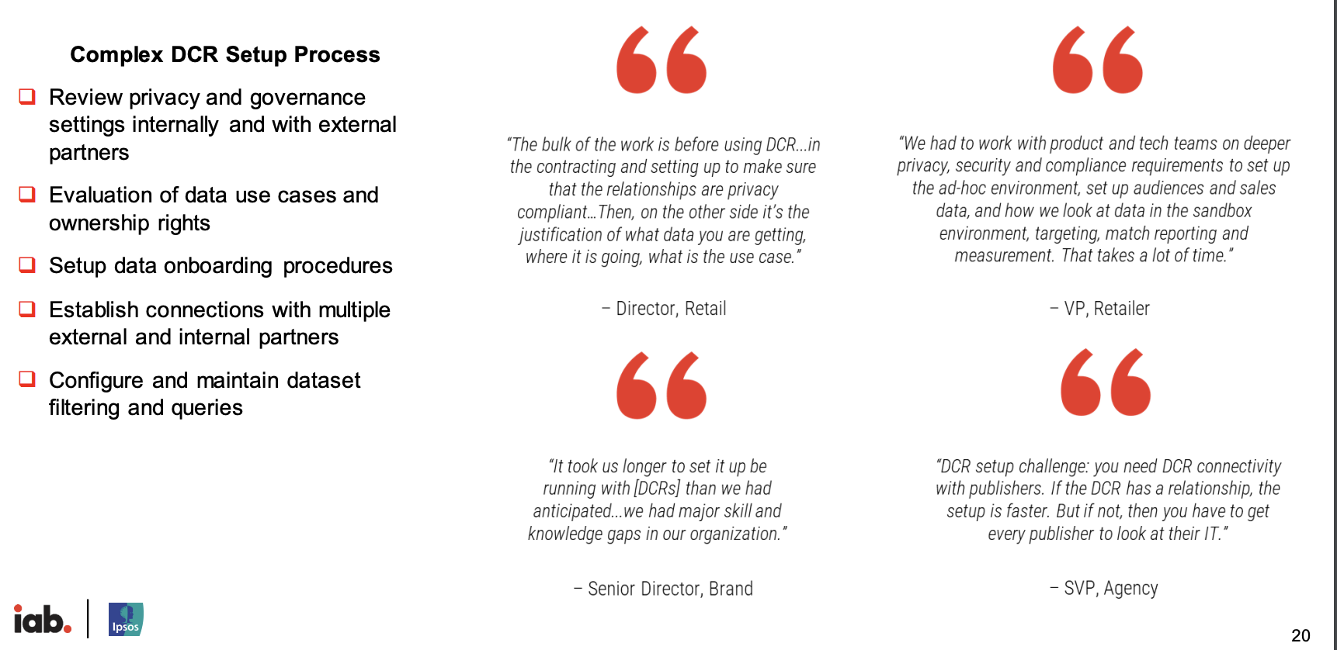

Source: [IAB State of Data](https://www.iab.com/wp-content/uploads/2023/01/IAB_State_of_Data_2023.pdf)

**The Need for Better First-Party Data Utilization**

As third-party cookies fade into the background, first-party data has become a critical asset. But many companies are failing to leverage their own data effectively. Disconnected systems, inconsistent data formats, and siloed operations often prevent businesses from gaining a unified view of their audience. Without this clarity, marketing strategies risk being misaligned, wasting precious resources on ineffective campaigns.

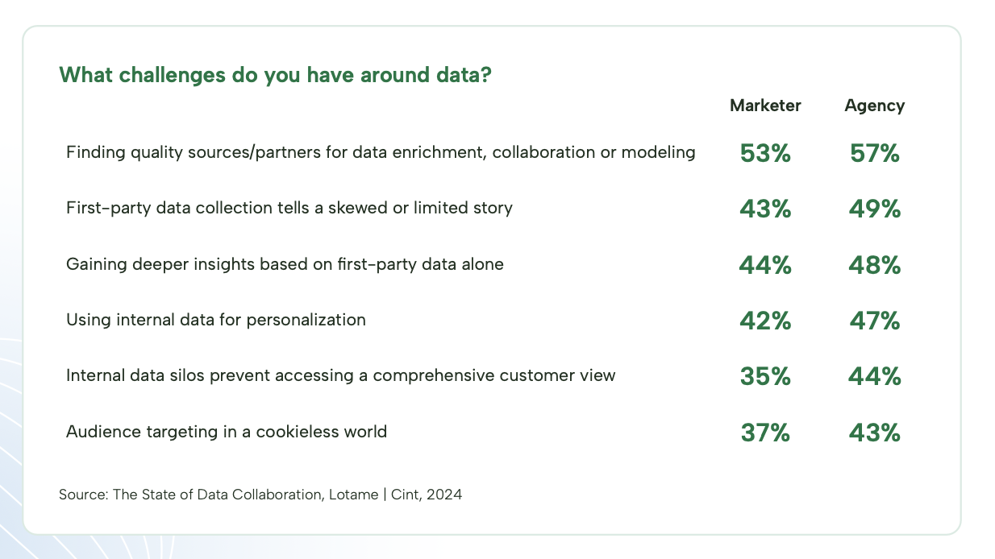

Source: [Lotame](https://resources.lotame.com/hubfs/2024%20State%20of%20Data%20Collaboration%20Research/Research-Data-Collaboration_Lotame-Cint.pdf), Cint Research

**Collaboration: The Key to Better Outcomes**

The solution lies in fostering deeper collaboration—both internally and externally. Internally, businesses must break down silos, integrate their data sources, and invest in tools that provide a holistic view of their audience. Externally, the focus should shift toward partnerships that enable privacy-first, seamless, and secure sharing of insights between first-party and third-party data owners. Efficient workflow and costs are key factors when considering best approaches for data collaboration.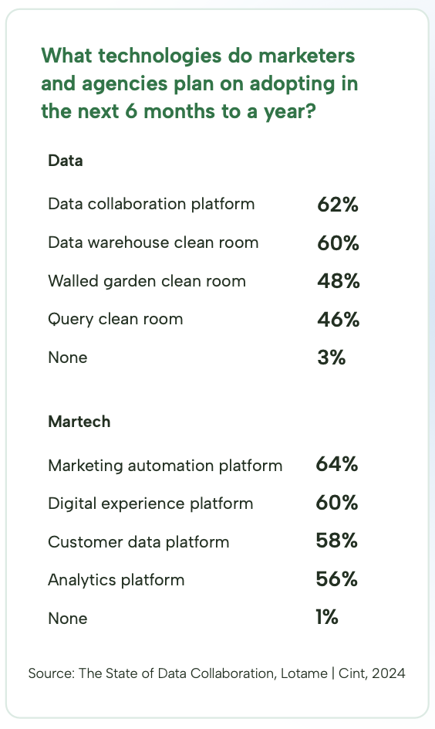

Emerging technologies are now paving the way for this level of collaboration. Privacy-preserving techniques such as differential privacy, federated learning, and advanced encryption methods allow businesses to work together without compromising compliance. When implemented effectively, these innovations can empower organizations to:

* Build richer audience segments by combining complementary datasets.
* Optimize campaigns in real time through shared insights.
* Maintain consumer trust with robust data protection measures.

**Driving the Next Wave of Marketing Success**

The dissatisfaction with data clean rooms underscores a broader need for transformation in how businesses manage and share data. Marketers must prioritize agility, speed to market, collaboration, and precision in their strategies. By rethinking their approach to first-party data and embracing next-generation solutions, companies can unlock unprecedented opportunities to drive better audience segmentation and marketing outcomes.

One emerging trend is to leverage a decentralized data collaboration method leveraging a Federated Data Model. We will dig deeper into this approach in a later blog but in a nutshell:

**Federated Data Model**

* Connects data from different sources virtually
* Provides a unified view of data from disparate sources without requiring physical data movement or consolidation
* Creates a virtual database that maps an enterprise’s many different sources and makes them accessible through a single interface
* Allows multiple databases to function as one and provides a single data source to front-end applications

The time to act is now. As the data landscape continues to evolve, those who adapt quickly will not only survive but thrive in the new era of data-driven marketing.

---------------------------------------------------------------------------------------

*Precise.ai is the leader in federated systems with its patented technology for private data networks that preserves privacy and security while seamlessly enabling data collaboration with other private networks and discovery of new data and insights. Data owners and marketers can unify and collaborate to enrich and activate their data for business outcomes all without having to move the data which drives faster speed to market, proof of provenance, and cost-efficiencies. Schedule time with Precise to learn more about how you can unlock the value of your data and join the Precise Private Data Network:* *Link to form*